PRACTICAL-1

AIM: Perform queries for DCL Commands and Locks.

GRANT Command:-[Granting privileges]
Granting privileges means to give permissions to some user to access database object or a part of database object. This command provides various types of access to database object such a table view & sequences.

REVOKE command:–[Revoking privileges]
Revoking privileges means to deny permissions to user given previously.The owner on an object a revoke privileges granted to another user. A user of the object who is not an owner but has been grant privileges using WITH GRANT OPTION can revoke privilege from the grant.

* Employee Table

Employee_number | Name | Age | City | Phone Number | Department
E1 | Ankit | 24 | Surat | 98211-26531 | Computer
E2 | Seema | 23 | Baroda | 98241-25421 | Computer
E3 | Saloni | 23 | Surat | 98751-53430 | IT
E4 | Anil | 26 | Surat | 98250-13518 | Computer
E5 | Rekha | 27 | Mumbai | 98251-51315 | IT

EXERCISE

Q-1: Give the user Seema all data manipulation permissions on the Employee.
Input:
SQL> Grant all on emp to Seema;
Output:-
Grant succeeded.

Q-2: Give the user Amit permission to only view and modify records in the employee table.
Input:
SQL>Grant select, update on emp to Amit;
Output:-
Grant succeeded.

Q-3: Give the permission of inserting the record in employee table to the user Ankit only.
Input:
SQL>Grant insert on emp to Ankit;
Output:-
Grant succeeded.

Q-4: Give the user Ivan all data manipulation privileges on the table Employee along with an option to further grant permission on the Employee table to other users.
Input:
SQL>Grant all on emp to Ivan with grant option;
Output:-
Grant succeeded.

Q-5: View the contents of the table Employee that belongs to Seema .
Input:
SQL>select * from emp where department =’Computer’;

Employee Number | Name | Age | City | Phone Number | Department
E1 | Ankit | 24 | Surat | 98211-26531 | Computer
E2 | Seema | 23 | Baroda | 98241-25421 | Computer
E4 | Anil | 26 | Surat | 98250-13518 | Computer

Q-6: Take all privileges given to the user Seema
Input: SQL>Revoke all on emp from Seema;
Output:-
Revoke succeeded.

Q-7: Take back the insert privileges on the table from Ankit
Input: SQL>Revoke insert on emp from Ankit;
Output:-
Revoke succeeded.

Q-8: Apply the row level lock whose employee number is E2.
Input: SQL>select * from emp where employee_number =’E2’ for update;

Employee Number | Name | Age | City | Phone Number | Department
E1 | Ankit | 24 | Surat | 98211-26531 | Computer
E2 (🔒 Locked) | Seema | 23 | Baroda | 98241-25421 | Computer
E3 | Saloni | 23 | Surat | 98751-53430 | IT
E4 | Anil | 26 | Surat | 98250-13518 | Computer
E5 | Rekha | 27 | Mumbai | 98251-51315 | IT

Q-9: Place an Exclusive lock whose department is computer.
Input: SQL> select * from emp where department =’Computer’ for update;

Employee Number | Name | Age | City | Phone Number | Department
E1 (🔒 Locked) | Ankit | 24 | Surat | 98211-26531 | Computer
E2 (🔒 Locked) | Seema | 23 | Baroda | 98241-25421 | Computer
E3 | Saloni | 23 | Surat | 98751-53430 | IT
E4 (🔒 Locked) | Anil | 26 | Surat | 98250-13518 | Computer
E5 | Rekha | 27 | Mumbai | 98251-51315 | IT

Q-10: Place an Exclusive lock on Employee table using LOCK TABLE statement.
Input: SQL>lock table emp in exclusive mode nowait;

Employee Number | Name | Age | City | Phone Number | Department
E1 (🔒 Locked) | Ankit | 24 | Surat | 98211-26531 | Computer
E2 (🔒 Locked) | Seema | 23 | Baroda | 98241-25421 | Computer
E3 (🔒 Locked) | Saloni | 23 | Surat | 98751-53430 | IT
E4 (🔒 Locked) | Anil | 26 | Surat | 98250-13518 | Computer
E5 (🔒 Locked) | Rekha | 27 | Mumbai | 98251-51315 | IT

PRACTICAL-2

AIM: Implement authorization, authentication, privileges on database.

Authentication: Authentication means verifying the identity of a user, device, or other entity who wants to use data, resources, or applications. Validating this identity establishes a trust relationship for further interactions.After authentication, authorization processes can allow or limit the levels of access and action permitted to that entity. You can authenticate both database and non database users for an Oracle database. For simplicity, the same authentication method is generally used for all database users, but Oracle Database allows a single database instance to use any or all methods.

Oracle Database requires special authentication procedures for database administrators, because they perform special database operations. Oracle Database also encrypts passwords during transmission to ensure the security of network authentication.

Minimum Requirements for Passwords: Oracle provides a set of minimum requirements for passwords. Passwords can be at most 30 bytes long. There are a variety of ways that you can secure passwords, ranging from requiring passwords to be of a sensible length to creating custom password complexity verification scripts that enforce the password complexity policy requirements that apply at your site.

Creating a Password by Using the IDENTIFIED BY Clause: SQL statements that accept the IDENTIFIED BY clause also enable you to create passwords. To create passwords for users, use the CREATE USER, ALTER USER, GRANT CREATE SESSION, or CREATE DATABASE LINK SQL statement. The following SQL statements create passwords with the IDENTIFIED BY clause.

CREATE USER Raj IDENTIFIED BY password;
GRANT CREATE SESSION TO Raj IDENTIFIED BY password;

Authorization and Privileges: Authorization permits only certain users to access, process, or alter data. It also creates limitations on user access or actions.The limitations placed on (or removed from) users can apply to objects such as schemas, entire tables, or table rows. A user privilege is the right to run a particular type of SQL statement, or the right to access an object that belongs to another user, run a PL/SQL package, and so on. The types of privileges are defined by Oracle Database.

Privileges can fall into the following general categories:

System privileges:-These privileges allow the grantee to perform standard administrator tasks in the database.

Object privileges:- Each type of object has privileges associated with it. Managing Object Privileges describes how to manage privileges for different types of objects.

Table privileges:- These privileges enable security at the DML (data manipulation language) or DDL (data definition language) level.Table Privileges describes how to manage table privileges.

View privileges:- You can apply DML object privileges to views, similar to tables. See View Privileges for more information.

Procedure privileges:- Procedures, including standalone procedures and functions, can be granted the EXECUTE privilege. See Procedure Privileges for more information.

Type privileges:- You can grant system privileges to named types (object types, VARRAYs, and nested tables). You grant privileges to users so they can accomplish tasks required for their jobs. You should grant a privilege only to a user who requires that privilege to accomplish the necessary work.
-Excessive granting of unnecessary privileges can compromise security.
For example, you never should grant SYSDBA or SYSOPER administrative privilege to users who do not perform administrative tasks.

You can grant privileges to a user in two ways:
- You can grant privileges to users explicitly. For example, you can explicitly grant to user Raj the privilege to insert records into the employees table.

2. You can grant privileges to a role (a named group of privileges), and then grant the role to one or more users. For example, you can grant the privileges to select, insert, update, and delete records from the employees table to the role named clerk, which in turn you can grant to users.

PRACTICAL-3

AIM: Perform queries to Create synonyms, sequence, index.

Synonym:
A synonym is an alternative name for database object such as tables, indexes, sequences.
A synonym can be used to hide the actual identity of the object being referenced.
For example, if there is a need to hide name of some particular table, then a synonym can be created to refer that table, hiding the original name.
Another use of the synonym is to abbreviate (Shorten) the table names, particularly tables from other users.

Sequences:
To distinguish different records of a table from each other, it is required that each record must have distinct values. The primary key constraint ensures this by not allowing duplicate or NULL values in columns defined as a primary key.
While entering data manually in INSERT or UPDATE operation, it is difficult to track such type of sequences. Data entry made by humans may involve gaps in sequences.

“A sequence is simply an automatic counter, which generates sequential numbers whenever required.”

- A sequence can be defined to
- Generate numbers in ascending or descending order
- Provide intervals between numbers and
- Caching of sequences numbers in memory to speed up their availability.

Index:
An Index is an ordered list of contents of the column ( or a group of columns ) of a table.
An index is similar to a table. It contains at-least two columns:

- A column having sorted data on which an index is created.
- A RowID is a unique identifier for each record inserted in a table.
- A column representing RowID for each row in a table

ASSUME TABLES:

- Emp:

Eno | Ename | Address | City | Ph_no | Qualification | Salary | D_no
E1 | Rahul | Prime | Surat | 98745679 | Be | 50000 | D1
E2 | Ravi | andheri | Baroda | 36776729 | Bcom | 30000 | D2
E3 | Ekta | Citylight | surat | 36728920 | llb | 62000 | D3

- Department:
D_no | D_name | Location
d1 | Be | 1st floor
d2 | Mca | 4th floor
d3 | ca | 2nd floor
d4 | Mtech | 3rd floor
d5 | It | 5th floor

EXERCISES

Q-1: Create synonym d1 for the table department in the system schema.
Input:
SQL>Create synonym d1 from system.dept;

Output:-Synonym created.

D_no | D_name | Location
d1 | Be | 1st floor
d2 | Mca | 4th floor
d3 | Bca | 2nd floor
d4 | Mtech | 3rd floor
d5 | It | 5th floor

Q-2: Drop Synonym.
Input:
SQL>Drop synonym d1;

Output:- Synonym dropped.

Q-3: Create Sequence empseq where maxval is 10,increment by 2,start with 1 with cycle and cache 4.
Input:
SQL>Create sequence empseq start with 1 increment by 2 minvalue 1 maxvalue 10 cycle cache 4;

Output:- Sequence created.
SQL> select * from emp;

Eno | Ename | Address | City | Ph_n | Qualification | Salary | D_no
E1 | Rahul | Prime | Surat | 98745679 | Be | 50000 | D1
E2 | Ravi | andheri | Baroda | 36776729 | Bcom | 30000 | D2
E3 | Ekta | Citylight | surat | 36728920 | llb | 62000 | D3

Q-4: Insert into emp table using empseq sequence.
Input:
SQL>insert into emp values(‘E’||empseq.nextval,’Raj’,’Adajan’,’Surat’,9985632101,’Be’,50000,’D1’ );

Q-5: Find the next value of empseq.
Input:
SQL>select empseq.nextval from emp;

Output:-
NEXTVAL
2
3
4
5
6
7
8
9

Q-6: Find the current value of empseq.
Input: SQL>select empseq.currval from emp;
Output:-
CURRVAL
9
9
9
9
9
9
9
9

Q-7: Drop Sequence empseq.
Input:
SQL>Drop sequence empseq;

Output:-Sequence dropped.

Q-8: Create index i1 on department table at dept_no& location.
Input:
SQL>create index i1 on dept(dept_no,location);

Output:- Index created.

Q-9: Show Index from department table.
Input: SQL>select rowid,dept_no,d_name,location from department;

Output:-

RowId | D_no | D_name | Location
AAAE/3AABAAAK/JAAA | d1 | Be | 1st floor
AAAE/3AABAAAK/JAAB | d2 | Mca | 4th floor
AAAE/3AABAAAK/JAAC | d3 | Bca | 2nd floor
AAAE/3AABAAAK/JAAD | d4 | Mtech | 3rd floor
AAAE/3AABAAAK/JAAE | d5 | It | 5th floor

Q-10: Drop Index from department table.
Input: SQL>Drop index i1;

Output:- Index dropped.

PRACTICAL-4

AIM: Perform queries to Create, alter and update views.

VIEW:
- “A view is a virtual or logical table that allows to view or manipulated part so the tables.”A view is derived from one or more tables, known as base tables. A view looks like and works similarly to normal tables. But, unlike tables, a view does not have storage space to store data.
- A view is created by a query, i.e. a SELECT statement, which uses base tables. Data for views are extracted from these base tables on specified query.
- Only definition of view is stored in the database. When a view is referenced in any SQL statement.
- Its definition is retrieved from database.
- A query specified in definition is executed.
- A view is created on top of the base tables.

ASSUMETABLES:

Emp:
Eno | Ename | Address | City | Ph_no | Qualification | Salary | D_no
E1 | Rahul | Prime | Surat | 98745679 | Be | 50000 | D1
E2 | Ravi | andheri | Baroda | 36776729 | Bcom | 30000 | D2
E3 | Ekta | Citylight | surat | 36728920 | llb | 62000 | D3

Department:
D_no | D_name | Location
d1 | Be | 1stfloor
d2 | Mca | 4thfloor
d3 | ca | 2ndfloor
d4 | Mtech | 3rdfloor
d5 | It | 5thfloor

EXERCISES

Q-1:Create a view from emp table such that it content city eno,ename.
Input:
SQL>Create view v_emp as select eno, ename from emp;
Output:-View created.
Select * from V_emp;

Output:-
Eno | Ename | City
E1 | Rahul | Surat
E2 | Ravi | Baroda
E3 | Ekta | surat

Q-2: Update view and change ename Ankit where eno is E1 and define the change in basic table.
Input: SQL>Update V_emp set ename=’Ankit’ where eno=’E1’;

Output:-1 row updated.
Select* from emp;

Eno | Ename | City
E1 | Ankit | Surat
E2 | Ravi | Baroda
E3 | Ekta | surat

Q-3: Create view view1 from emp table & department table contains in the column eno & ename from emp table and dno & dname from department table where dno is same to both table.
Input: SQL>Create view View1 as select e.eno,e.ename,d.dno,d.dname from emp e, dept d where e.dno=d.dno;

Output:-
View created. Select *from view1;
Eno | Ename | D_no | D_name
E1 | Rahul | D1 | Be
E2 | Ravi | D2 | Mca
E3 | Ekta | D3 | Bca

Q-4:Drop view View1.
Input:
SQL>Drop view View1;
Output: View dropped.

Practical – 6

AIM:- How To Download, Install & Run MongoDB Server in Windows.

How to Download & Install MongoDB on Windows:-
➢ The following steps can be used to download and install MongoDB on Windows 10.

Step 1:- Download MongoDB Community Server :-
Go to link and Download MongoDB Community Server.
We will install the 64-bit version for Windows.

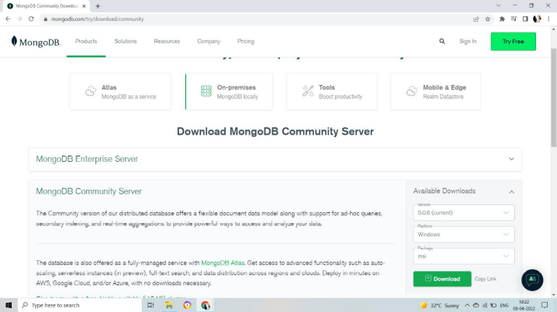

Step 2:-Click on Setup
Once download is complete open the msi file.

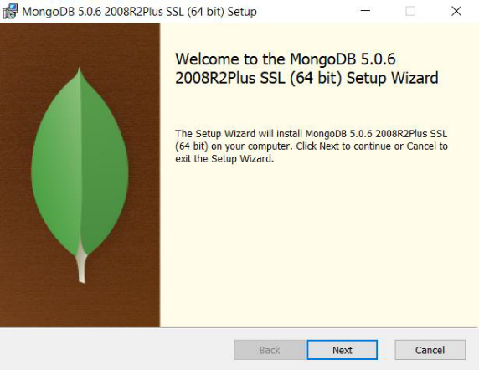

Step 3:-Click on next

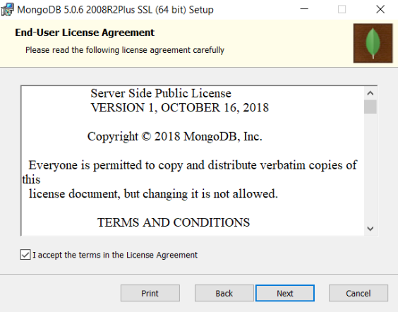

Step 4:-Accept the End-User License Agreement
1. Accept the End-User License Agreement
2. Click Next

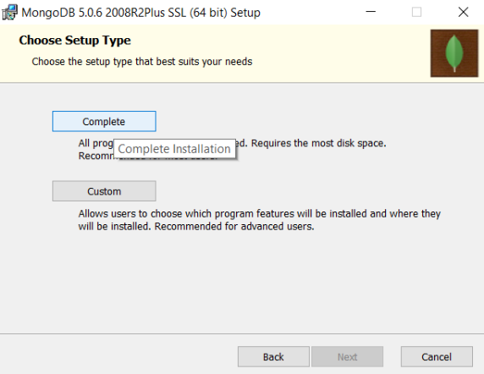

Step 5:-Click on the “complete” button
➢Click on the “complete” button to install all of the components. The custom option can be used to install selective components or if you want to change the location of the installation.

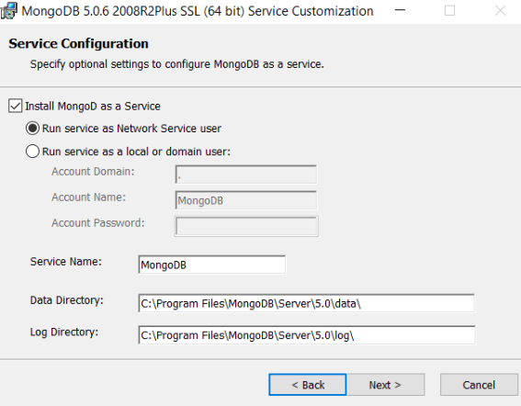
Step 6:- Service Configuration
1. Select “Run service as Network Service user”. make a note of the data directory, we’ll need this later.
2. Click Next

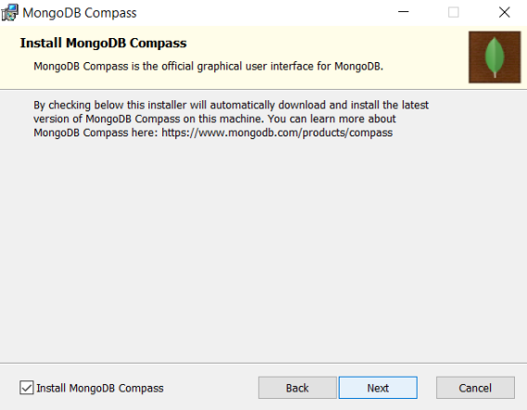

Step 7:-Click on next

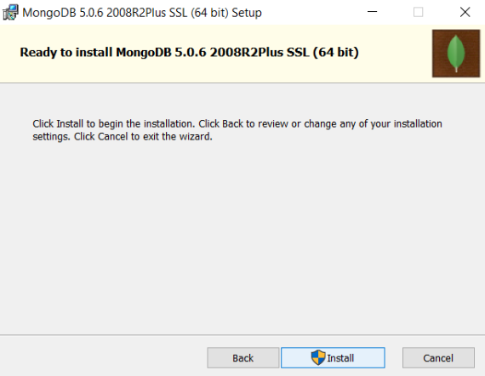

Step 8:-Click on install

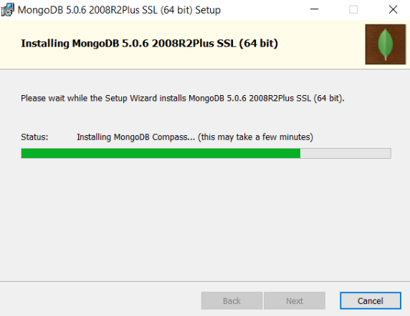

Step 9:- Click on Finish

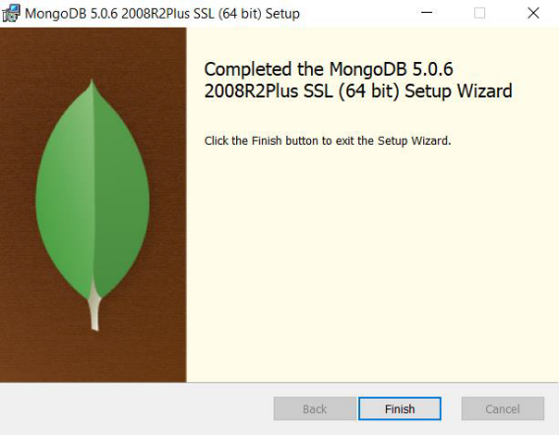

Step 10:-Click on start using compass

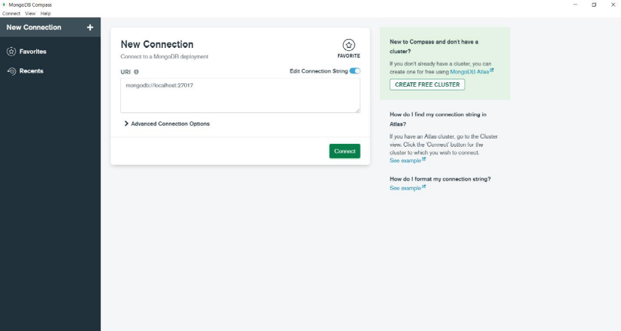

• Configuration: -
Step 1: - Go to the local disk C and get into ProgramFiles.

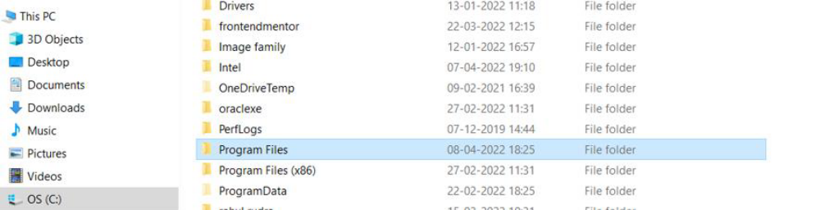

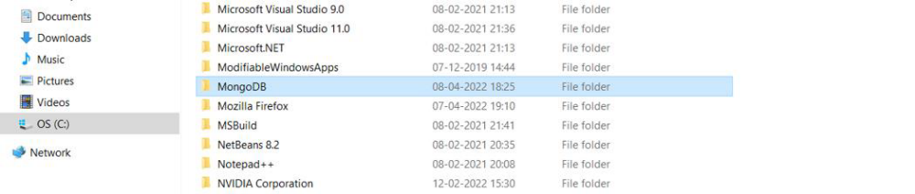
Step 2: - Open it and you’ll find a folder named “bin” i.e., binaries folder.

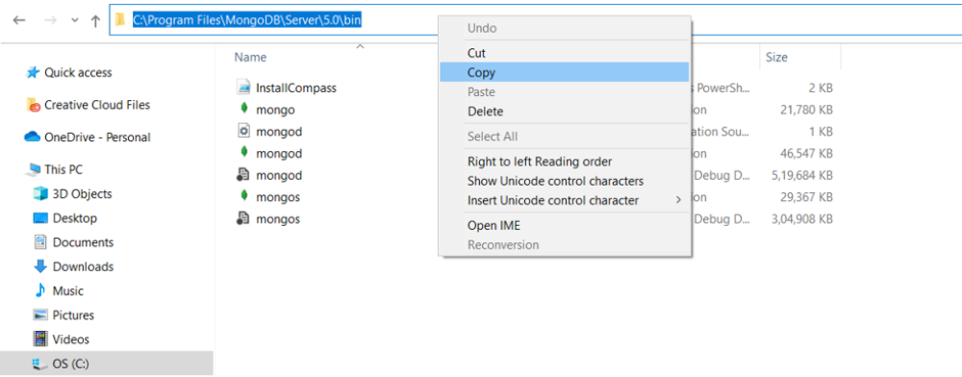

Step 3: - You will have 5 to 7 files in it. Copy the path, as given in the snippet path i.e., C:\Program Files\MongoDB\Server\5.0\bin

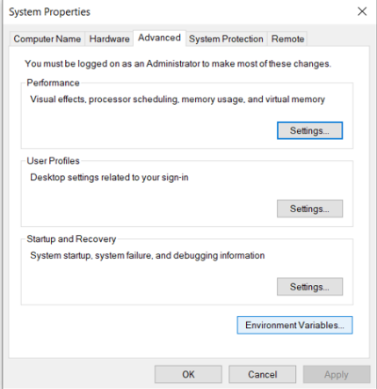

Step 4: - Open Settings and search “Edit environment variable”.
The options given below would pop up in front of you:

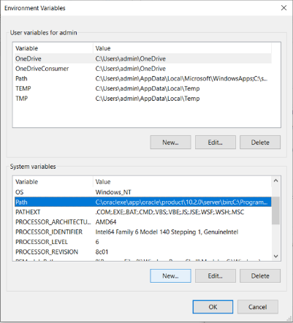

Step 5: - click on path and add a new file
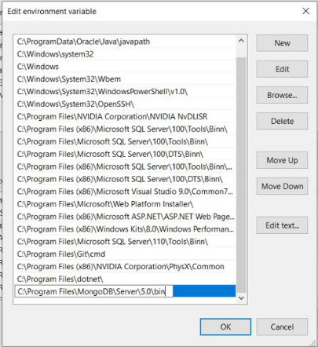

Step 6: - paste the path of bin folder here. Click on ok

Step 7: - Open Command prompts and type “mongo-version” to start the service. You can see a mongo version 5.0.6 here
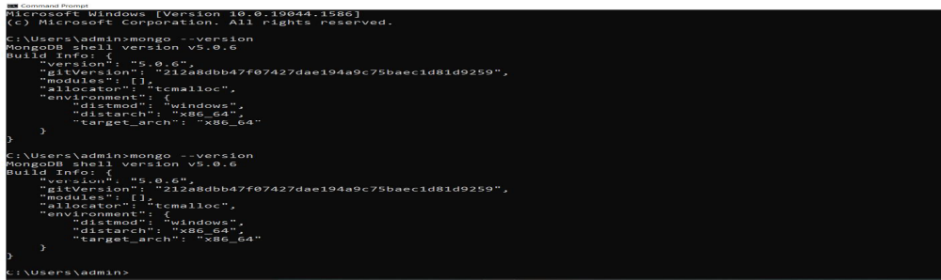

• HOW TO CONNECT A MONGO DB TO LOCAL HOST:-
Step 1: - click on connect button to connect the local host
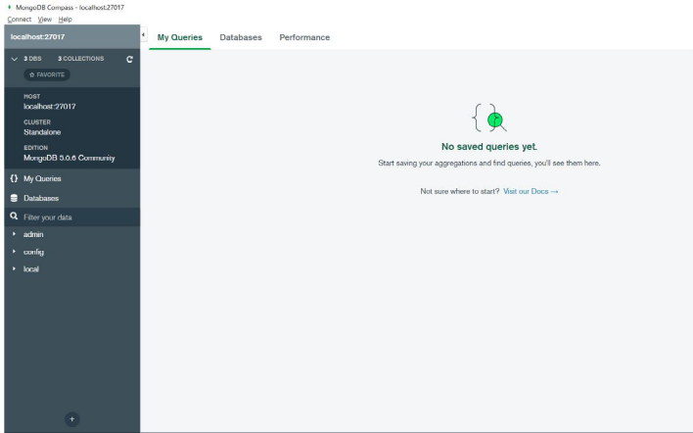
Step 2: - Now you will connect to local host
• HOW TO CREATE A DATABASE IN MONGODB :-

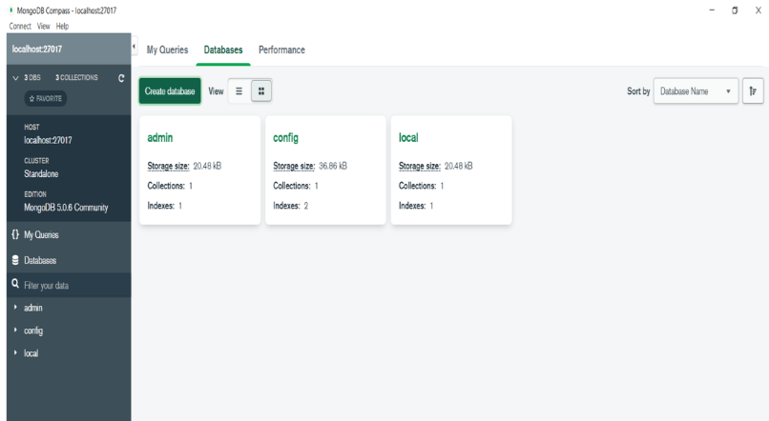

Step 1: - click on create database to create new user.
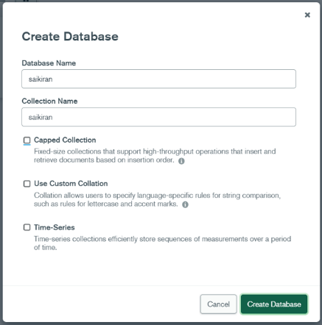

Step 2: - Given a Database name and collection name as shown in the fig. and then click on create database

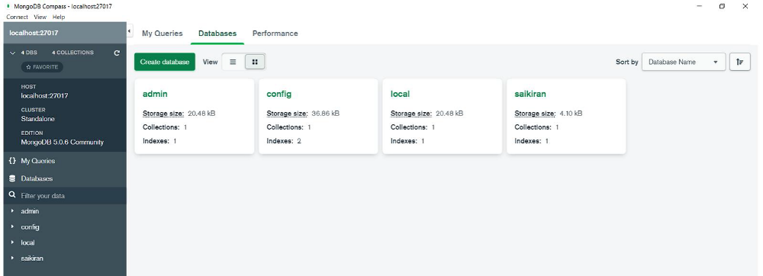

Step 3: - Now you can see your created database here.

